**Switches- Slide and Tactile**

**Slide Switch**

For the slide switch, the middle prong is the input prong, while the two outer prongs are the output. The side the switch is on is the side that the output is currently on. For this exercise, it shows how you can use the switch to change what the Arduino Uno is doing. The digital pins in the Arduino Uno can be used as either input or output, so in this exercise, the switch has two different inputs into the Arduino, which will cause two different actions to occur. In the exercise, the actions are just turning on an LED, but the code can be altered as needed.

**NOTE:** When the digital pins are set to input without a constant current running through them, they are extremely sensitive and it can be difficult to use them in this manner.

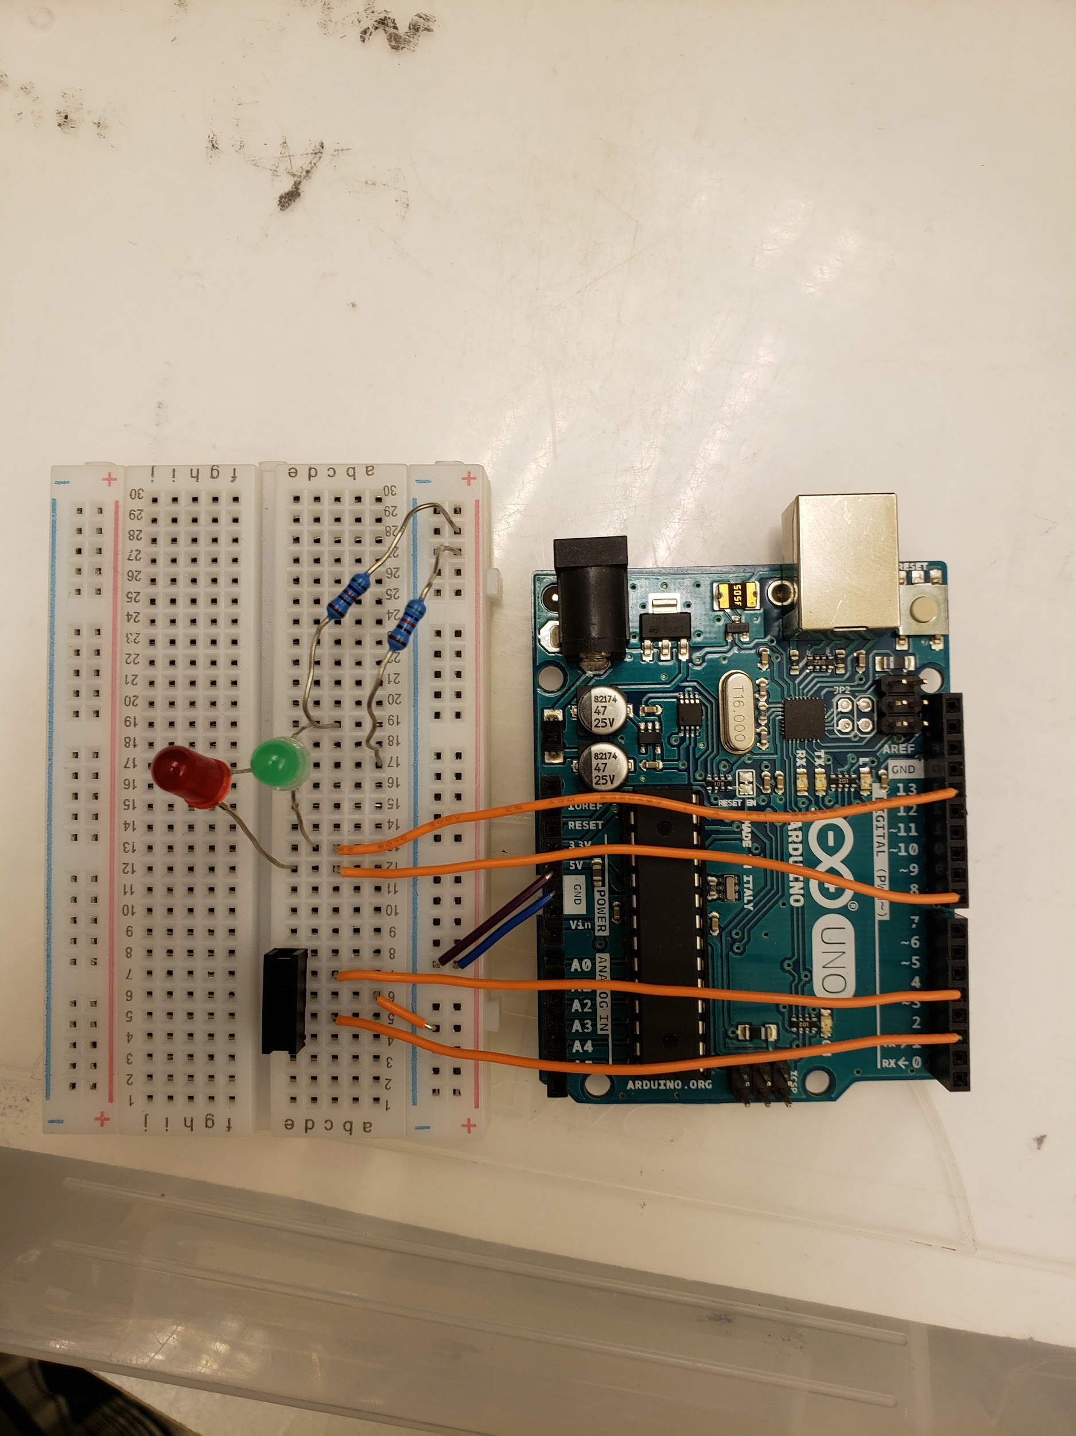

**Tactile Switch**

For the tactile switch, the four prongs are actually two parallel strips of metal, where there is no connection between the prongs on the same side of the switch unless the button is pressed. In this exercise, you learn how to make the Arduino wait until the button is pressed before actions are executed, which, in this case, is just making an LED blink. Of course, this can be substituted with whatever code you want to put in there. (Same note as above)

